BURFORD PARISH COUNCIL
You are summoned to attend a meeting of Burford Parish Council at 7.30pm on Thursday 8th July 2021 at Burford Village Hall

Members of the public are welcome to join the meeting. Please contact the Clerk as places are limited due to Covid restrictions.
Signed: 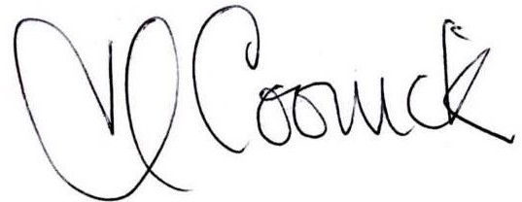 (Locum Parish Clerk) Date: 2nd July 2021

AGENDA

- Election of Chair and Vice Chair and Declaration of Acceptance of Office
- Declaration of Acceptance of Office as Parish Councillors and Completion of Disclosable Pecuniary Interest Forms
- Appointment of Locum Clerk and Agree Pay Rate and Expenses
- Apologies for absence (please notify the Clerk prior to the meeting)
- Declarations of Interest and Dispensations: The Council will receive disclosures of pecuniary and personal interests from Members on matters to be considered at the meeting.
- Public involvement session. Members of the public are able to ask a question or make a statement. If it is not possible to respond at the meeting, a written response will be provided at a later date.
- To receive Minutes of last meeting held on 1st March 2021
- Co-option to fill two remaining seats on the Council following last election
- Set the Dates of the Public Rights period
- Report on the Playground
- Finance:
  - Financial report and banking arrangements
  - Payments:
RPS Ground Maintenance
Insurance

- Report from Shropshire Unitary Councillor, Richard Huffer

- Village Hall Update

- To consider draft advert for Parish Clerk/Responsible Finance Officer.

- Correspondence received for attention as identified during handover.

- Any urgent items affecting the Parish not of a policy of financial nature.

- To consider dates and time for Future Meetings

Copies of the agenda and minutes are available from the Locum Clerk, Heather Coonick: burfordparishcouncil.co.uk burfordparishcouncil@gmail.com Tel: 07817607355.

